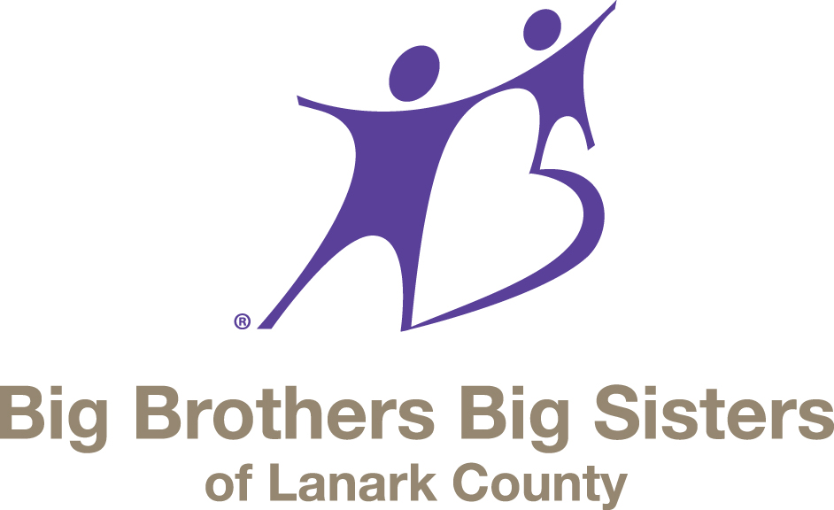

2017 Annual Report

Our Vision

To provide every child in Lanark County who needs a mentor with a mentor.

Our Mission

Big Brothers Big Sisters of Lanark County is a not for profit volunteer organization which helps children develop to their unique potential through consistent, dependable and non-conditional adult friendship.

Our Values

We believe all children should be given the opportunity to reach their full potential. In providing these opportunities, the children will enhance their personal development as well as become engaged citizens in their community.

We believe that by changing the course of young lives we can in turn be changing the course of our community’s future. That it could lead to a reduction in poverty and unemployment; to safer schools and neighbourhoods; to a renewed optimism for growth. We believe that it has the potential to lead to change on a broader, more far-reaching scale.

We believe that opening a child’s eyes to "what is" opens his/her mind to "what could be."

We are Big Brothers Big Sisters of Lanark County, and we believe in the value of mentoring.

Board of Directors – 2017

Chair – Sue Cavanagh
Vice Chair – Katie Ireton / Kim Sumara
Treasurer – Beth Cozens / Carole Fuller
Secretary – Dawn Risebrough / Lynn Miskelly
Past Chair – Linda Hewson / vacant

Directors
Jamie Campbell, Sue Wright, Tammy Edwards, Amanda Neadow, Kim Sumara
and Lynn Miskelly

Agency Staff – 2017

Jennifer Miller – Executive Director
Cliff Woods – Manager of Program Impact and Effectiveness
Beth Sinclair – Resource Development Manager
Sandra Walker – Jewel’s Store Manager Smiths Falls
Margaret Swanson – Jewel’s Store Manager Perth
Kiefer Vincent – Mentoring Coordinator
Ashley Struthers – Mentoring Coordinator
Jon Valentin – Supervisor of Program Delivery
Sherry Burke – Agency Promoter
Natalie Downing – After School Program Facilitator/Mentoring Coordinator
Emily Gray – Mentoring Coordinator
Sandra Burelli – Mentoring Coordinator
Sarah Dingwall – After School Program Facilitator/Mentoring Coordinator
Bridget Manahan – Manager of Youth Services
Ashley Rankie – Youth ASP Facilitator
Heidi McNeely – Youth ASP Facilitator
Angie Beaupre – After School Program Facilitator
April Taillefer – Agency Promoter
Shawnee Clement – Facilitator
Jennifer Hogan – Office Administrator

A fond farewell to:
Ashley Struthers, Kiefer Vincent and Sherry Burke – Staff
Katie Ireton, Linda Hewson and Beth Cozens – Board

With special thanks to:

Kara Saumure, Summer Student

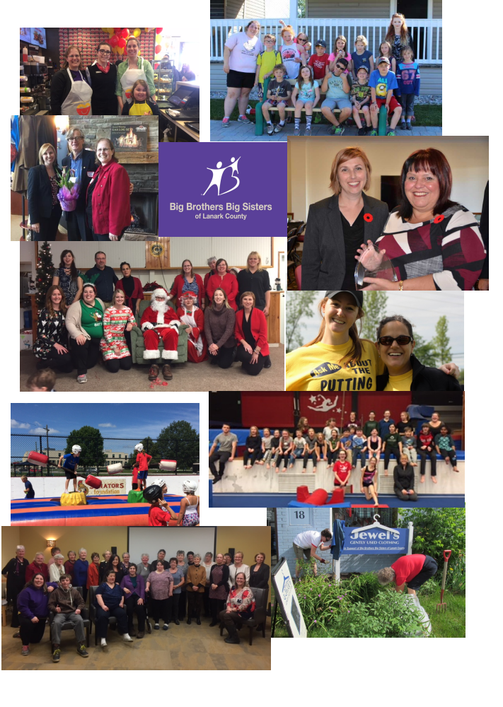

Letter from the Board Chair
Submitted by Sue Cavanagh, Board Chair

Highlights of 2017:

The impact of mentoring stories that staff shared at board meetings brought the real life impact of the work of staff, volunteers and children and illustrated the central focus of BBBS to everyone at the table.

The Board’s trust and support of the ED spoke to the cohesiveness of the group. Jennifer continued to work diligently, with drive, compassion and humour, gently prodding and encouraging board and staff.

We were, once again, in a financially solid position. Projected deficits that transformed into surpluses indicated a well managed organization. There was an incredibly wide array of fundraising approaches with cumulative results. The list was exhaustive and the results were impressive!

We served a lot of kids in 2017. A record number, in fact, with programs spread across the County. Yet, when another opportunity presented itself, BBBS took on, morphed, massaged and delivered on the inclusion of Youth Services in Smiths Falls in partnership with the town and several agencies with funding from Lanark County. This is a further indication of the positive influence of this agency in the community and the determination and ingenuity of the staff to rise to challenges.

With 2018 comes accreditation and all that entails. The strategic plan action items were rolled into the agency workplan and work began in earnest to prepare for accreditation. I am confident that we will be served well by the highly capable staff and the outcome will be a positive one.

The new minimum wage increase in 2018 will have an impact on the organization. We know that staff will benefit from increased salaries. Administration will determine the effect on the bottom line and develop strategies to mitigate the overall financial impact.

I wish extend deep gratitude to Jennifer and all of the staff for your amazing energy and commitment to BBBS.

Thanks to the board for your steady hand at the helm.

Thank you to all of our funders – far and wide, large and small. Your donations count!

A Word from the Executive Director
Submitted by Jennifer Miller

When we look back at the agency history in another 50 years, I am certain that 2017 will be the year that we will remember as the one with the most operational changes. A new youth program was added, a number of new staff hired, 2 satellite offices were opened, and several partnerships began. It will also be a time in our history where we can be proud about the impact we have had on local children and youth – a historical high of 675 kids served throughout Lanark County.

In the summer of 2017 the local Smiths Falls Youth Centre closed, and we received a call from the Town asking us to work with them to create a new after school program for area youth. We brought on YAK Youth Services from Perth, and within 8 weeks we launched We Are Kids (WAK) a new youth service for young people in grades 7 through 12. Within the first two months 40 young people registered.

Also during the summer months, the agency partnered with the Town of Smiths Falls to run summer programming. 59 children took part. This was by far the best effort we have made yet to serve area children in the summer.

Funding grew to help us serve more children, with Bowl for Kids at its highest revenue ever. Donations, Jewels sales, and other events were all up. Having extra funding meant we were able to add more staff, and now boast the largest casework team ever. Bursting at the seams with staff, the agency opened a small office at Perth & District Collegiate Institute and one at the Smiths Falls Youth Arena. This allowed us to free up extra space at Jewels Perth, which was needed to accommodate their growing business.

The Board of Directors had interesting and challenging conversations around ethical fundraising, opening new doors for future funding partners. They also worked through a discussion about social enterprise growth, and invested in an overhaul of Jewels Smiths Falls.

We are fortunate to continue to serve Lanark County in a meaningful way, and to be able to have and build on the capacity to answer the call when we are needed.

Big Brothers Big Sisters of Lanark County
Mentoring Team Annual Report

In 2017 Big Brothers Big Sisters of Lanark County served a total of 654 children and youth across our mentoring programs. In particular, our After School Program and Go Girls Program continued to expand across the county. Our relationships with community partners remained strong, allowing us to provide our mentoring programs to more children and youth than ever before.

As 2017 came to a close the Mentoring team proved to be a very strong and cohesive group of individuals. The diversity of each of the team members work experiences proved to be valuable in dealing effectively with any issue or concern that may have presented itself over the course of the year. Change seems to be a constant in the makeup of the mentoring team and 2017 was no different. Kiefer Vincent and Ashley Struthers, two of our Mentoring Coordinators and Shawnee Clement, an After School Program Facilitator, left us. There were also changes to job responsibilities and roles. Jon Valentin assumed the role of Supervisor of Service Delivery. Emily Grey and Natalie Downing took on new roles as Mentoring Coordinators. Sandra Burelli was hired as a new Mentoring Coordinator. Sarah Dingwall and Angie Beaupre were brought onto the team as After School Program Facilitators. Cliff Woods took on the role as Manager of Program Impact and Effectiveness.

The Mentoring Team was very proud of the quality of work they accomplished by providing these life impacting, mentoring relationships. The team was honoured and privileged to be part of the lives of the children, youth, parents and guardians and volunteers who chose to be part of this great agency.

In addition to a great staff complement, Big Brothers Big Sisters of Lanark County offered practicum opportunities to college students to complete their required placements. In 2017 we provided placements for first and second year Algonquin College Social Services Worker program students, for a Community Justice Program student from Fleming College and to a third year BSW student from Carleton University.

Community Based Program (Big Brothers, Big Sisters, Big Couples)

The core program of Big Brothers Big Sisters of Lanark County continues to be our Community Based program of matching a child one to one with a caring adult mentor as a Big Brother or Big Sister. Growth within this program remains a priority but we understand the ongoing challenge in recruiting dedicated and committed volunteers, especially males to fill the need for mentors across the county. Our numbers for 2017 showed a slight decrease in our number of matches. A total of 32 children and youth were served in Community Based matches.

The decrease in number of matches can be attributed to some of our long term matches feeling they had established a positive relationship and did not really need our continued support. As older matches closed new matches were established as new mentors completed the screening process.

The Mentoring team is committed to expanding and growing the number of community based matches we have. New volunteer recruiting strategies and a focus on skills based mentoring will be rolled out in 2018

In School Mentoring Program (Adult, Co-op, Youth in Care, College Placement)

Our In School Mentoring program continued to provide valuable one to one relationships for children and youth in our local schools. A total of 59 children and youth were mentored in our Adult, Co-op, Youth In Care and College Placement Students In School Mentoring programs.

The number of children and youth served in this program also showed a decrease over 2016 numbers. For the first time in many years BBBS Lanark County did not have secondary school co-op student completing their placement with us.

Go Girls! Healthy Bodies, Healthy Minds

In 2017 a total of 158 girls attended 13 Go Girls programs at 11different schools across the county. Programs were offered in Perth at St. John Intermediate and North Elmsley Public School, in Lanark at Maple Grove Public School, in Smiths Falls at St Francis de Sales, Chimo Public School and Lombardy Public School, in Carleton Place at Notre Dame Catholic High School, Arklan Public School and Beckwith Public School and in Almonte at ADHS and Naismith Memorial Public School.

Game On Eat Smart Play Smart

Unfortunately due to the lack of male mentors we were not able to offer the Game On program to any schools in 2017.

Canadian Tire After School Program

Our After School program expanded in 2017 to offer this very popular program at nine different schools. Two of those schools offered the program two nights a week for a total of 11 programs.

In the spring of 2017 we offered the program at Glen Tay PS, The Stewart School, St John CS, Queen Elizabeth PS, St Francis de Sales, Caldwell PS, Arklan PS and Naismith Memorial PS.

Over the course of the summer we reviewed where we would offer the program and in September we continued to offer the After School Program at Naismith Memorial PS, Caldwell PS, The Stewart School, Queen Elizabeth PS, St. John CS and St Francis de Sales. We then expanded the program to offer it at new schools; R. Tait PS, St Mary’s CS and Duncan J Schoular PS. In addition to the new sites we offered the After School program two nights a week at Queen Elizabeth and Duncan J. In total 305 children participated in these programs.
Other Site Based Programs

The summer of 2017 saw Big Brothers Big Sisters of Lanark County offer a Summer Program in partnership with the Town of Smiths Falls and the Sens Foundation. The eight week program offered a number of sports games and activities as well as mentoring activities to children ages 6 to 12. A total of 56 children and youth participated in this summer program.

With the closure of the Smiths Falls Youth Centre at the end of the summer 2017, BBBS Lanark, YAK and the Town of Smiths Falls formed a partnership to provide a Youth After School Program. Staff were hired, the program was developed and opened in October 2017. The program offered a number of opportunities and activities for the youth, aged 13-18, of Smiths Falls to participate in. 40 youth were served in the last few months of 2017 in this program.

In 2017 a total of 654 children and youth were involved in some way in one of our life impacting mentoring programs. We expanded our programs to service more schools and more communities as the need for mentors continues to grow. We recruited and screened volunteers in a timely manner ensuring programs could be run efficiently and effectively. The dedication and commitment of our Mentoring Team and of all of our volunteers ensured that we continued to meet our mission of “To provide every child in Lanark County who needs a mentor with a mentor.”

Fund Development Report
Submitted by Beth Sinclair

Fund Development Overview 2017

Big Brothers Big Sisters’ agencies in Canada are not funded by the Federal or Provincial government. Our agency locally has been in existence for 45 years, and nationally BBBS has been in Canada for over 100 years. To ensure we provide safe and effective mentoring programs for local children, we employ trained and experienced Social Service Workers. We believe that mentoring changes the lives of children. In 2017 we saw another increase in the number of children we served through our mentoring programs.

This care and concern costs money. We have always felt that in order to sustain ourselves over the long haul we need to diversify our sources of funding, so if one year we could not get support from one funder, we didn't put our programming in jeopardy. In 2017 our revenue came from the following sources;

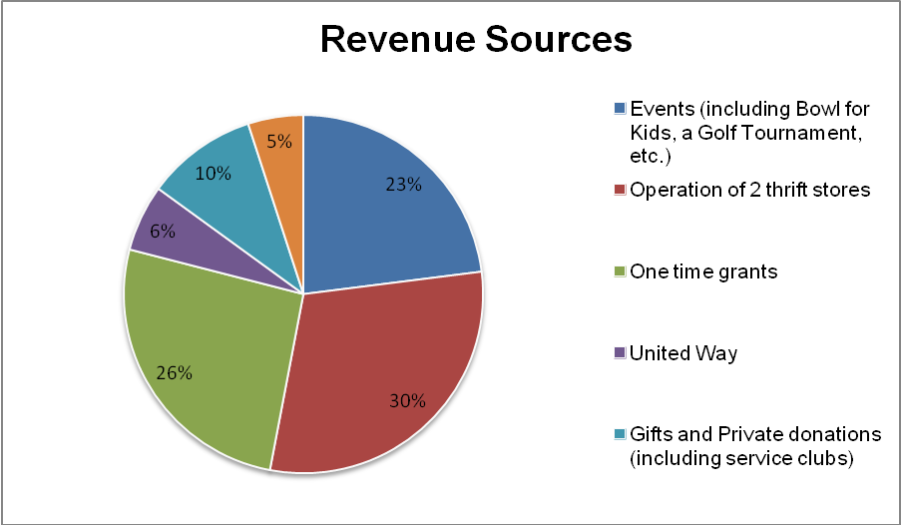

As illustrated above, key partners include United Way; two Jewel’s Gently Used Clothing stores (BBBS run Social Enterprises), Municipal Support, Grants (including ones from Ministry of Education, Ministry of Tourism, Culture and Sport; Canadian Tire and Jumpstart, etc…); Individuals, Corporations, and Service Clubs. Big Brothers Big Sisters of Lanark County is also proud to involve the community in its fundraising through classic events such as Tim Hortons Bowl for Kids Sake (which raised over $94,000 in 2017), 3M Golf for Kids Sake, and Tim Hortons/Kinsmen Curl for Kids Sake. BBBSLC has found by diversifying revenue sources the agency is able to continually grow and serve more children and youth.

Committee Reports

Nominating Committee
Submitted by Kim Sumara, Committee Chair

The 2017 nominating committee was made up of Kim Sumara (chair), Dawn Risebrough (secretary), and Jennifer Miller (staff liaison).

The board underwent some changes in the year with the resignation of Laurie Weir, Beth Cozens, Katie Ireton and Linda Hewson. Re-joining the board we welcomed returning member, Carole Fuller.

The board also underwent an amendment to Agency Bylaw #5 stating:

The affairs of the agency shall be managed by the Board of Directors hereinafter referred to as the Board, constituted from the membership of the agency and consisting of eleven (11) members.

Be changed to read:

The affairs of the agency shall be managed by the Board of Directors, hereafter referred to as the Board, constituted from the membership of the agency and consisting of eight (8) members.

The committee met on October 23, 2017 to update the Nominating Committee terms of Reference Planning Worksheet.

We are pleased to announce that we will be taking part in governance training, being offered by United Way this spring.

The nominating committee would like to thank all board members for their dedication to their roles on the board and to the overall mission of Big Brothers Big Sisters of Lanark County!

Respectfully submitted by Kim Sumara

Fund Development Committee
Submitted by Tammy Edwards and Amanda Neadow, Committee Members

Big Brothers Big Sisters of Lanark County (BBBSLC) has worked hard to diversify its streams of revenue during its 45 years of serving the Lanark County Community. BBBSLC does not receive sustainable government funding, requiring it to rely heavily on Community Partners to provide the funding needed to raise its entire budget.

Events such as Tim Hortons Bowl for Kids Sake, 3M Golf for Kids Sake, Tim Hortons and Kinsmen Curl for Kids Sake, and Dine Out Day contributed to 23 percent of the funds raised in 2017. Without the support of Sponsors and participation of the community these events would not be as successful as they are.

The two Jewel’s Gently Used Clothing (thrift stores) have been invaluable Social Enterprise Ventures for the agency. In 2017 these two volunteer run stores raised approximately 30 percent of the budget necessary to maintain and grow Big Brothers Big Sisters of Lanark County. These stores are a huge asset to the agency, providing great visibility and an additional location for customers and clients to connect with BBBSLC.

BBBSLC has also benefited in 2017 from Ministry of Education, Ministry of Tourism, Culture and Sports, Canadian Tire and Jump Start funds, and other one-time grants. These grants that staff applied for contributed to approximately 26 percent of the 2017 budget.

Furthermore, the United Way has continued to be a key partner, raising community awareness and financially supporting BBBSLC. In 2017, BBBSLC was the highest funded agency in Lanark County by the United Way.

Municipal support continues to grow, as the community has shown their appreciation and recognition of the work that is being done by BBBSLC through mentoring and changing the lives of local children and youth. Along with providing one time grants, many of the town councillors and staff of various municipalities BBBSLC serves participate in agency events such as Tim Hortons Bowl for Kids Sake and 3M Golf for Kids Sake. Staff of BBBSLC are treated with great kindness and appreciation when presenting at municipal meetings.

Another 10 percent of the budget that was raised in 2017 came from private donations and gifts, memorial donations, and service clubs, et. al. Last year there was a great turnout at the 2nd Annual Donor Appreciation Breakfast. Individuals and Corporations choosing BBBSLC as their Charity of Choice is key in the agency being able to continue to do the impactful work that it does in the community.

In 2017 the Fund Development Committee was revitalized which has led to great idea generation and ambitious plans for 2018 (including a special breakfast for Professionals regarding Planned Giving).

BBBSLC is grateful for all of the various streams of funding that it received in 2017, providing it with opportunities to expand and serve more children and youth than ever before.

Governance Committee
Submitted by Lynn Miskelly, Committee Chair

The Governance Committee reconvened in October 2017 after the June AGM with committee members Jamie Campbell, Sue Cavanaugh and Lynn Miskelly under the skilled guidance of staff representative Cliff Woods. The first order of business for the committee was to appoint a chair, review the Terms of Reference for the Governance Committee and make recommendations for changes to the board for approval. Priorities for the committee were also established to prepare for the upcoming agency accreditation in the spring of 2018.

The committee implemented the Executive Director review and Board self evaluation and looked at a number of agency policies. Bill 148 was reviewed and it’s implication to the agency. It was very reassuring to see that almost all of the items were covered in existing policies and only 2 minor revisions to policies were recommended to the board to meet the intent of Bill 148.

The Governance Committee is a very interesting committee. Thank you to Cliff Woods, staff representative, and the other committee members. I look forward to another term on this committee.

Submitted by

Lynn Miskelly
Governance Committee Chair

Finance Committee
Submitted by Carole Fuller, Committee Chair

The 2017 year started out with a challenge to the agency to offset a budget that would be utilizing prior year funds. The goal was to continue providing the same level of programs to our community that we were able to provide the year before.

The agency met this goal, and exceeded it, allowing the same commitment for 2018.

We saw the community get behind the agency and raise over $94,000 in our first big event of the year, Bowl for Kids.

Community partners with local businesses added to the success and provided for the after school programs.

Not to rest on what we have done, the Agency stepped in to fill the gap for youth programming when the local youth centre was unable to continue. This endeavor was possible with the support of the Town of Smiths Falls, the County of Lanark, the Province and YAK, Perth.

We would never want to forget what doesn’t show up on the financial statement and that would be the value of the time all of our volunteers commit and our staff who go above and beyond.

Respectfully submitted,

Carole Fuller

