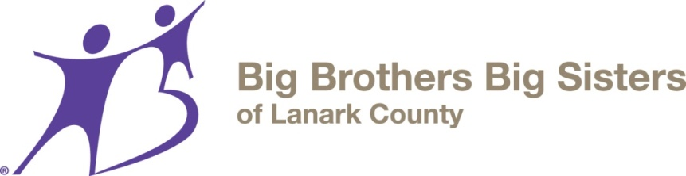

WAK (we are kids) Youth Program Registration

YOUTH’S INFORMATION
Name: _______________________________________ Male Female Other___________________
Date of Birth: ______________________ Grade: _______
Phone Number: _______________________________________________________________________
Cell Number: __________________________________________________________________________
E-mail address ________________________________________________________________________

PARENT/GUARDIAN INFORMATION
Parent/Guardian’s Name: ____________________________________________________________________
E-mail address: ____________________________________________________________________________
Address: _____________________________________________________________________________
City: Postal Code: _ _____
At what phone number can you best be reached: __________________________________________

Please check this box if you wish to receive information about events for your child, programs, updates, agency newsletters and opportunities. These updates are emailed once every 1-3 months.

GETTING TO KNOW YOUR YOUTH

Please check any of the following characteristics that describe your child:

- Friendly
- Outgoing
- Shy
- Withdrawn
- Active
- Helpful
- ______________
- _____________

Please check any of the following that describes your child’s interests:

- Cooking
- Music
- Board/Card Games
- Building (Lego)
- Sports
- Animals
- Arts/Crafts
- Reading/Books
- Movies/TV
- Talking
- Computers
- Video Games
- ______________

Relationships:

Does your youth generally get along with his/her peers? Please comment
______________________________________________________________________________________________________________________________________________________________________________________________________________________________________________________________________________________________________________________________________________________________

Has your youth experienced:
Bullying
Aggression
Behavioral issues
Smoking
Drug or alcohol use
Please comment:
______________________________________________________________________________________________________________________________________________________________________________________________________________________________________________________________________________________________________________________________________________________________

Medical History:

Does your child have any specific medical conditions, allergies or other concerns we should know about? If yes, please describe: ____________________________________________________________________________________________________________________________________________________________________________________________________________________________________

Is your child on any medication? ( ) Yes ( ) No

If yes, please explain.
________________________________________________________________________________________________________________________________________________________

Other:

Is there anything you would like us to be aware of that would assist us. If yes, please describe: ____________________________________________________________________________
________________________________________________________________________________________________________________________________________________________________________________________________________________________________________________________________________________________________________________

______________________________________________ ________________________
Parent/Guardian Signature Date
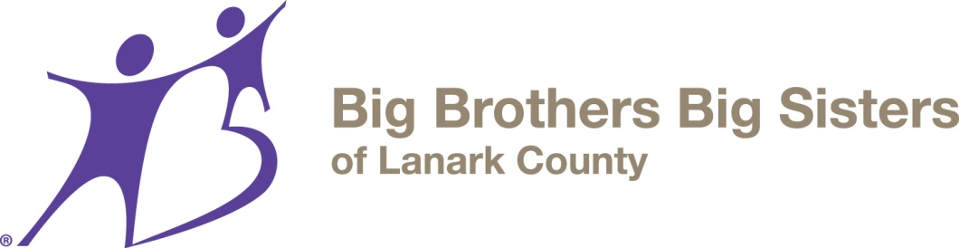

Informed Consent (Site Based group program) - Parent

I hereby give permission to Big Brothers Big Sisters of Lanark County (BBBSLC) to make available their service to my child. It is my understanding that the intention of the Agency is to offer my child an opportunity to participate in a group program lead by a responsible adult, (minimum 18 years old, however, where appropriate supervision takes place, the volunteer may be younger), I understand that all efforts will be made to select a responsible Mentor who will facilitate the group program.

In consideration for this service and other valuable consideration provided to my child by BBBSLC, I release the agency of all responsibilities and liabilities in connection to their services provided in good faith, to myself or my child. I permit the agency to release any relevant information, including my personal information, to Big Brothers Big Sisters of Canada and their insurers, as may be appropriate in connection with any legal proceeding, inquiry or risk thereof.

I understand that the collection of personal information about me or my child will be held in strict confidence and is to be used solely for the purposes of administering the program. I further agree that information about my child may be shared, at the discretion of BBBSLC, with the group facilitator so that my child’s needs may be best met.

I understand that this application is the property of BBBSLC. I also agree that my child will participate in the Pre- Match Training Program administered by BBBSLC

I HAVE READ AND UNDERSTAND THIS AGREEMENT. BY SIGNING THIS AGREEMENT, I ACKNOWLEDGE THAT:

I, ______________________, the parent/guardian of ______________________ hereby request Big Brothers Big Sisters service for my child. I give my child permission to participate in one or more group programs offered by BBBSLC. I am aware of and understand the risks, dangers and hazards associated with the above service and agree such service is suitable for my child.

Signed at ____________________ this ______ day of ____________________, 20____.

_____________________________________________
Parent/Guardian

Site Based Program Media Consent

From time to time, group photos of Mentees and Mentors are used to help us in our recruitment of volunteers. This includes use in community newspapers, photo albums, bulletin boards or being displayed in the office. This could include other promotional purposes such as for a slide or video show, promotional material included in media/information kits, or newsletters.

This consent form is required to enable us to use these photos. Please indicate below whether you do or do not give consent. You cooperation is appreciated.

I, (print your name)______________________________________, parent/guardian of

(print name of your child)______________________________________,

(check one) ( ) do ⁪ ( ) do not ⁪

consent to photos of my child being published for publicity purposes,

(check one) ( ) do ⁪ ( ) do not ⁪

consent to my child’s first name (only) to be used for publication.

Signed this __________ day of _____________________________, 20_____.

_________________________________ ________________________________
Parent / Guardian’s Signature Mentoring Coordinator – BBBS of Lanark County

