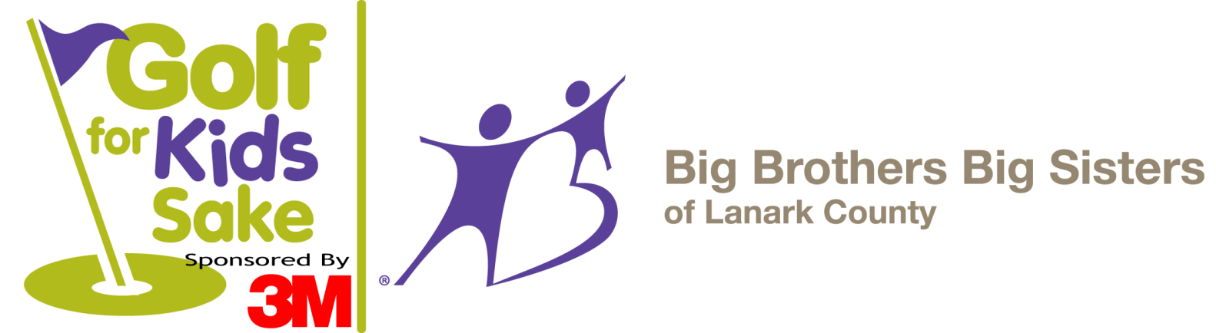

Saturday, May 26th, 2018

Mapleview Golf Course – Perth

9:00 a.m. Shot Gun Start

$85 per person (Members $65)

Register and pay by May 7th and save $5!

Includes Cart, Continental breakfast and BBQ lunch

Bid to Win!
WestJet tickets on the silent auction table.
Travel anywhere WestJet flies!

Call 613-283-0570
Or visit www.bigbrothersbigsisterslanark.ca
Register early to avoid disappointment!

Did You Know…
A groundbreaking study by The Boston Consulting Group demonstrates the power of investment
in Big Brothers Big Sisters mentoring programs to deliver strong economic value over time.

The study was designed to audit the financial return to society from Big Brothers Big Sisters, and it found
that every dollar invested generates on average $18 in hard dollar returns to society.

Thank you for supporting mentoring in Lanark County.
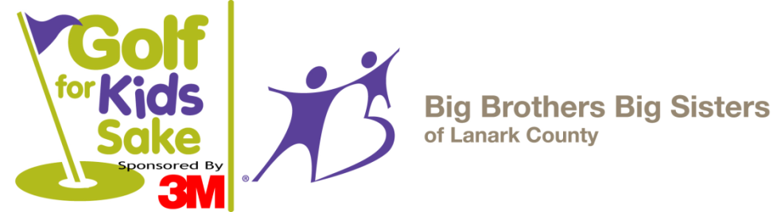
Registration Form

Saturday, May 26th, 2018

Mapleview Golf & Country Club
R. R. # 3, Perth, ON (3km West of Perth on the Scotch Line)
$85.00 per person (Members $65.00) includes cart,
18 holes of golf, BBQ lunch and a continental breakfast!
Also featuring a Silent Auction, fun games, prizes, and more!

Schedule of Events
Golf | 4 person scramble (best ball)
9:00 a.m. | Shot Gun Start (BBQ lunch during the tournament)
3:00 p.m. | Dessert, Silent Auction and prizes!

Please tear off and return by May 14th, 2018
--------------------------------------------------------------------------------------------------------------------------------------------------------------------------------------------

Player One  Name: _________________________________  Email: ___________________________________  Address: _________________________________  Phone: _________________________________ | Player Two  Name: _________________________________  Email: ___________________________________  Address: _________________________________  Phone: _________________________________
Player Three  Name: _________________________________  Email: ___________________________________  Address: _________________________________  Phone: _________________________________ | Player Four  Name: _________________________________  Email: ___________________________________  Address: _________________________________  Phone: _________________________________

Big Brothers Big Sisters of Lanark County  18 William St. E., Smiths Falls, ON  K7A 1C2  Phone: 613-283-0570 - Fax: 613-283-2251  jennifer.miller@bigbrothersbigsisters.ca | Please make cheques payable to:  Big Brothers Big Sisters  Tax receipts for $25 per person  available upon request.  Full address must be provided

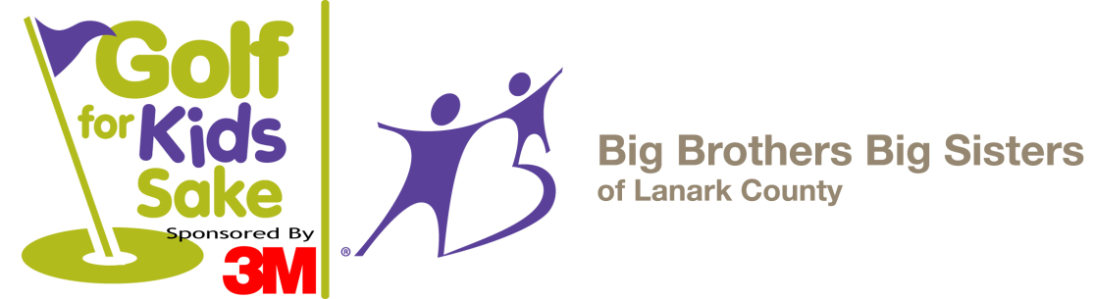

Hole Sponsorship Form
For more sponsorship opportunities,
please call Beth Sinclair or Jennifer Miller at 613-283-0570

Event Date: Saturday May 26th, 2018

Hole sponsorship helps offset the costs of the event so that dollars brought in by participants can go directly to agency programs. Big Brothers Big Sisters of Lanark County served 654 children in 2017 through life changing mentoring programs. Your support is truly valued.

Hole Sponsorship Cost = $100.00 included white placard sign at a hole on the course with your business name printed in black. Your name/business name will also be in the thank you ad after the event.

Big Brothers Big Sisters of Lanark County  18 William St. E., Smiths Falls, ON  K7A 1C2  Phone: 613-283-0570  Fax: 613-283-2251  jennifer.miller@bigbrothersbigsisters.ca | Please make cheques payable to:  Big Brothers Big Sisters of Lanark County

Information to be displayed on sign
- Check here if you will be emailing us your logo

Business Name

Mailing Address

Contact Name

Phone / Email

