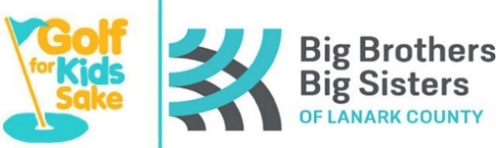
Registration Form
Saturday August 29th, 2020
Mapleview Golf & Country Club
R. R. # 3, Perth, ON (3km West of Perth on the Scotch Line)
$90.00 per person (Members $70.00) includes Cart,
18 holes of Golf, BBQ lunch
Also featuring a Silent Auction, fun games, prizes, and more!
Please call (613) 264-1235 or 1-888-755-7552
to book your tee time and fill it in at the bottom of registration sheet

Schedule of Events
Golf | 4 person scramble (best ball)
8:00 a.m. | First Tee Time Start & continue every 10 minutes
2:00 p.m. | Last tee time available (BBQ lunch available during play)

Please tear off and return by August 7th, 2020
--------------------------------------------------------------------------------------------------------------------------------------------------------------------------------------------
Player One  Name: _________________________________  Address: _________________________________  Phone: _________________________________  Email: _________________________________  Member □ Tax Receipt □ | Player Two  Name: _________________________________  Address: _________________________________  Phone: _________________________________  Email: _________________________________  Member □ Tax Receipt □
Player Three  Name: _________________________________  Address: _________________________________  Phone: _________________________________  Email: _________________________________  Member □ Tax Receipt □ | Player Four  Name: _________________________________  Address: _________________________________  Phone: _________________________________  Email: _________________________________  Member □ Tax Receipt □

Our Tee Time is booked with Mapleview for: ________________________ (8 am – 2 pm)
Big Brothers Big Sisters of Lanark County  18 William St. E., Smiths Falls, ON  K7A 1C2  Phone: 613-283-0570  Fax: 613-283-2251  angie.beaupre@bigbrothersbigsisters.ca | Please make cheques payable to:  Big Brothers Big Sisters of Lanark County  Tax receipts for $20 per person available  upon request before December 31, 2020.  Full mailing address is required!

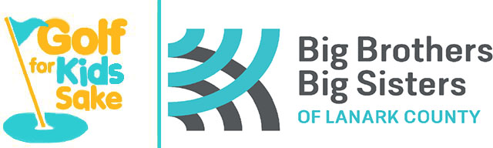

Hole Sponsorship Form
For more sponsorship opportunities,
please call Angie Beaupre at 613-283-0570

Event Date: Saturday August 29th, 2020

Hole sponsorship helps offset the costs of the event so that dollars brought in by participants can go directly to agency programs. Big Brothers Big Sisters of Lanark County served close to 700 children in 2019 through life changing mentoring programs. Your support is truly valued.

Hole Sponsorship Cost = $100.00, which includes white placard sign at a hole on the course with your business name printed in black. Your name/business name will also be in the social media thank you after the event.

Big Brothers Big Sisters of Lanark County  18 William St. E., Smiths Falls, ON  K7A 1C2  Phone: 613-283-0570  Fax: 613-283-2251  angie.beaupre@bigbrothersbigsisters.ca | Please make cheques payable to:  Big Brothers Big Sisters of Lanark County

Information to be displayed on sign
- Check here if you will be emailing us your logo
(jpg please)

Business Name

Mailing Address

Contact Name

Phone / Email

