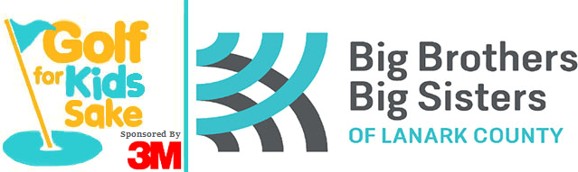
Registration Form
Saturday June 12th, 2021
Mapleview Golf & Country Club
2856 Scotchline Road, Perth
$90.00 per person (Members $70.00) includes Cart,
18 holes of Golf, BBQ lunch
Also featuring a Silent Auction, fun games, prizes, and more!
Please call (613) 264-1235 or 1-888-755-7552
to book your tee time and fill it in at the bottom of registration sheet

Schedule of Events
Golf | 4-person scramble (best ball)
8:00 a.m. | First Tee Time Start & continue every 10 minutes
2:00 p.m. | Last tee time available (BBQ lunch available during play)
Please tear off and return by mail or email by May 28th, 2021
--------------------------------------------------------------------------------------------------------------------------------------------------------------------------------------------
Player One  Name: _________________________________  Address: _________________________________  Phone: _________________________________  Email: _________________________________  Member □ Tax Receipt □ | Player Two  Name: _________________________________  Address: _________________________________  Phone: _________________________________  Email: _________________________________  Member □ Tax Receipt □
Player Three  Name: _________________________________  Address: _________________________________  Phone: _________________________________  Email: _________________________________  Member □ Tax Receipt □ | Player Four  Name: _________________________________  Address: _________________________________  Phone: _________________________________  Email: _________________________________  Member □ Tax Receipt □

Our Tee Time is booked with Mapleview for: ________________________ (8 am – 2 pm)
Big Brothers Big Sisters of Lanark County  18 William St. E., Smiths Falls, ON  K7A 1C2  Phone: 613-283-0570  Fax: 613-283-2251  angie.beaupre@bigbrothersbigsisters.ca | Please make cheques payable to:  Big Brothers Big Sisters of Lanark County  Tax receipts for $20 per person available  upon request before December 31, 2021.  Full mailing address is required!

Hole Sponsorship Form
For more sponsorship opportunities,
please call Angie Beaupre at 613-283-0570

Event Date: Saturday June 12th, 2021
Hole sponsorship helps offset the costs of the event so that dollars brought in by participants can go directly to agency programs. Big Brothers Big Sisters of Lanark County served hundreds of children through life changing mentoring programs. Your support is truly valued.

Hole Sponsorship Cost = $100.00, which includes white placard sign at a hole on the course with your business name printed in black. Your name/business name will also be in the social media thank you after the event.

Big Brothers Big Sisters of Lanark County  18 William St. E., Smiths Falls, ON  K7A 1C2  Phone: 613-283-0570  Fax: 613-283-2251  angie.beaupre@bigbrothersbigsisters.ca | Please make cheques payable to:  Big Brothers Big Sisters of Lanark County or BBBSLC
Information to be displayed on sign
- Check if emailing your logo
(jpg please)

Business Name

Mailing Address

Contact Name

Phone / Email

