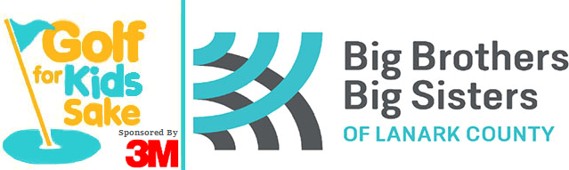

Registration Form

Saturday May 25, 2024

Mapleview Golf & Country Club

2856 Scotchline Road, Perth

$110.00 per person (Members $90.00) includes Cart,

18 holes of Golf, BBQ lunch

Also featuring an Online Auction with two WestJet tickets up for bid,

fun games, prizes, and more!

|  |  |
| --- | --- |
| **Schedule of Events** | |
| Golf | 4-person scramble (best ball) |
| 8:00 a.m. | Registration & Breakfast Start |
| 9:00 a.m. - 3:00 p.m. | Shot Gun Start (BBQ lunch available during play) |

**Please tear off and return by Friday May 15th, 2024**

--------------------------------------------------------------------------------------------------------------------------------------------------------------------------------------------

|  |  |
| --- | --- |
| **Player One**  Name: _________________________________  Address: _________________________________  Phone: _________________________________  Email: _________________________________  Member □    Tax Receipt □ | **Player Two**  Name: _________________________________  Address: _________________________________  Phone: _________________________________  Email: _________________________________  Member □    Tax Receipt □ |
| **Player Three**  Name: _________________________________  Address: _________________________________  Phone: _________________________________  Email: _________________________________  Member □   Tax Receipt □ | **Player Four**  Name: _________________________________  Address: _________________________________  Phone: _________________________________  Email: _________________________________  Member □ Tax Receipt □ |

|  |  |
| --- | --- |
| Big Brothers Big Sisters of Lanark County  18 William St. E., Smiths Falls, ON  K7A 1C2  Phone: 613-283-0570  Fax: 613-283-2251  angie.beaupre@bigbrothersbigsisters.ca | Please make cheques payable to:  **Big Brothers Big Sisters of Lanark County**  Tax receipts for $20 per person available  upon request before December 31, 2024.  Full mailing address is required! |



Hole Sponsorship Form

For more sponsorship opportunities,

please call Angie Beaupre at 613-283-0570

Event Date: Saturday May 25th 2024

Hole sponsorship helps offset the costs of the event so that dollars brought in by participants can go directly to agency programs. Big Brothers Big Sisters of Lanark County served hundreds of children through life changing mentoring programs. Your support is truly valued.

Hole Sponsorship Cost = $100.00, which includes white placard sign at a hole on the course with your business name printed in black. Your name/business name will also be in the social media thank you after the event.

|  |  |  |
| --- | --- | --- |
| Big Brothers Big Sisters of Lanark County  18 William St. E., Smiths Falls, ON  K7A 1C2  Phone: 613-283-0570  Fax: 613-283-2251  angie.beaupre@bigbrothersbigsisters.ca | | Please make cheques payable to:  **Big Brothers Big Sisters of Lanark County or BBBSLC** |
| Information to be displayed on sign   * **Check if emailing your logo**   **(jpg please)** |  | | |
| Business Name |  | | |
| Mailing Address |  | | |
| Contact Name |  | | |
| Phone / Email |  | | |